# Spreadsheet errors and fixes

When you are new to data analytics — and sometimes even when you are not — spreadsheet struggles are real. It never feels good when you type in what you are sure is a perfect formula or function, only to get an error message. Understanding errors and how to fix them is a big part of keeping your data clean, so it’s important to know how to deal with issues as they come up, and more importantly, not to get discouraged.

Remember, even the most advanced spreadsheet users come across problems from time to time. In this reading, you will learn about common error messages and how to fix them.



But before we do that, let’s go over a few best practices and helpful tips. These strategies will help you avoid mistakes in the first place, making your life in analytics a whole lot less stressful:

1. Filter data to make your spreadsheet less complex and busy.
2. Use and freeze headers so you know what is in each column, even when scrolling.
3. When multiplying numbers, use an asterisk (*) not an X.
4. Start every formula and function with an equal sign (=).
5. Whenever you use an open parenthesis, make sure there is a closed parenthesis on the other end to match.
6. Change the font to something easy to read.
7. Set the border colors to white so that you are working in a blank sheet.
8. Create a tab with just the raw data, and a separate tab with just the data you need.

Now that you have learned some basic ways to avoid errors, let’s talk about what to do when that dreaded pop-up does appear. Use the following list to track down the most common spreadsheet errors and fix them.

**Tip:** If you are new to spreadsheets, this is an opportunity to be introduced to the errors. In the sections that follow, focus on the descriptions of the errors in the first paragraphs, and then come back to the examples after you have worked with spreadsheets a bit more. Knowing what these errors mean takes some of the fear out of getting them!

## ****#DIV/0!****

A #DIV/0! error means that your formula or function is asking the spreadsheet to divide something that is impossible to divide. That could be a zero (0) or, more commonly, an empty cell. Just like in ordinary arithmetic, dividing something by zero or nothing at all gives you an answer with no meaning. So, the solution here is to divide by another number or add a value to the blank cell.

**Example (add value): C2 -** In the example below, you will notice that we have an error in C2. The formula bar shows that the value for this cell is the result of dividing cell B2 by cell B3. B3 has a zero value. To fix this error we need to insert a value in B3 that isn't 0, or use the IF function to let the spreadsheet know not to run the calculation if the cell value of B3 is 0.

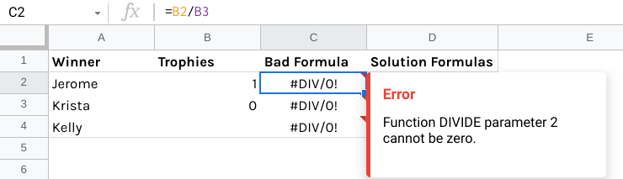Screenshot of a spreadsheet. Columns A through D are labeled: Winner, Trophies, Bad Formula, Solution Formula. In column A, the table lists Jerome, Krista, and Kelly. In B, it lists 1, 0, and a blank cell. Every cell in the Bad Formula column lists a #DIV/0! Indicating an error. A pop error states “Error: function DIVIDE parameter 2 cannot be 0”]

**Solution (add value)**: **D2 -** One possible solution is to use =IF(B3,B2/B3,0) to indicate that the solution should be 0 if the dividing parameter-- B3-- is 0. In other words, if the cell value for B3 is 0, the spreadsheet ignores the calculation of B2/B3 and simply inserts 0 as the result in D2.

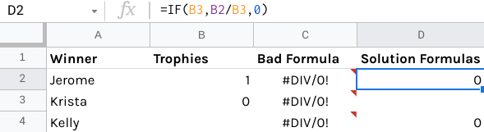Same table as the previous example; now cell D2 in the Solution Formulas has been selected. The cell contains a 0. The formula reads: =IF(B3,B2/B3,0).]

**Example (add value): C3**

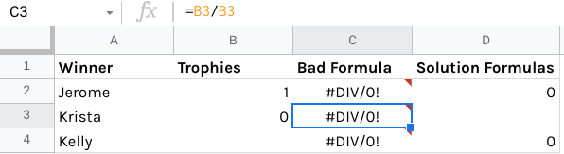Same table as the previous example; cell C3 has been highlighted. The cell contains a #DIV/0! Error. The formula reads “=B3/B2]”

**Solution (add value)**: **D3 -** Similarly, you could use =IF(B3,B2/B3," ") to indicate that the solution should be blank if the dividing parameter-- B3-- is 0. In other words, if the cell value for B3 is 0, the spreadsheet ignores the calculation of B2/B3 and simply leaves D3 empty (blank).

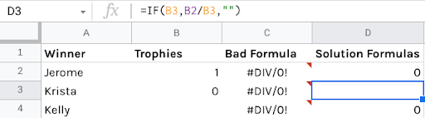

**Example (add value): C4**

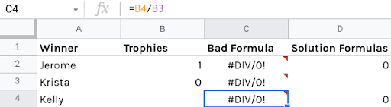

**Solution (add value)**: **D4 -** Or you could use the QUOTIENT function in **=IF(B3,QUOTIENT(B2,B3),0)** to divide B2 by B3, and make the solution 0 if the dividing parameter is 0.

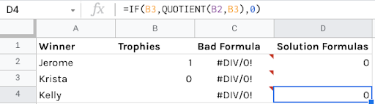Same table as the previous example. Cell D4 has been highlighted. It contains a 0. The formula reads “=IF(B3,QUOTIENT(B2,B3),0).”

**Example (change cell range): D13** Using the formula **=SUMIFS(C8:C10,$B$2:$B$4,"Blue",$A$2:$A$4,"Rachel")/SUMIFS(C8:C10,$A$2:$A$4,"Rachel")** isn’t possible because the dividing parameter is still 0.

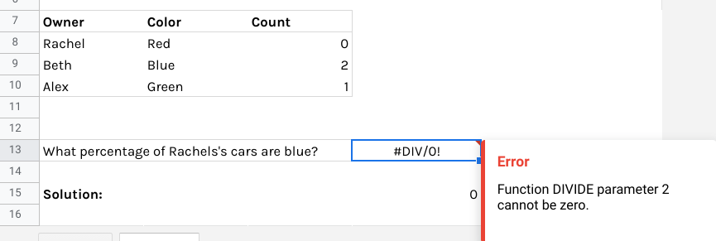Spreadsheet table with three columns: Owner, Color, and Count. Under Owner, it lists Rachel, Beth, and Alex. Under Color, it lists Red, Blue, Green. Under Count, it lists 0, 2, 1. Underneath the table, there is a question: “What percentage of Rachel’s cars are blue?” Next to this question in cell D13 is a #DIV/0! Error. The formula reads “=SUMIFS(C8:C10,$B$2:$B$4, “Blue”, $A$2: $A$4, “Rachel”)/SUMIFS(C8:C10,$A2:$A4,”Rachel”).”

**Solution (change cell range): D15** But we can use the formula **=IFERROR(SUMIFS(C8:C10,$B$2:$B$4,"Blue",$A$2:$A$4,"Rachel")/SUMIFS(C8:C10,$A$2:$A$4,"Rachel"),0)** to indicate that we want the solution to be 0 if there is an error in the formula.

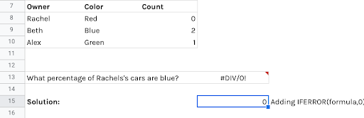Same spreadsheet as the previous example. Now, cell D15 is selected; the formula reads “ =IFERROR(SUMIFS(C8:C10,$B$2:$B$4, “Blue”, $A$2: $A$4, “Rachel”)/SUMIFS(C8:C10,$A2:$A4,”Rachel”), 0).” In cell E15, the solution is explained: “Adding IFERROR(formula,0)” solved this error.”

## ****#N/A****

An #N/A error tells you that the numbers in your formula or function can’t be found by the spreadsheet application. Generally, this means the data doesn’t exist. This can happen for a number of reasons. For example, you might have accidentally deleted a number or row. Later on, you’ll learn about referencing a different spreadsheet. So another reason you get the #N/A error is because one of the spreadsheets was deleted. In the example below, you will notice that we have #N/A errors in cell C10 and C11. To figure out why these errors are showing up we will need to look at the contents of the cell.

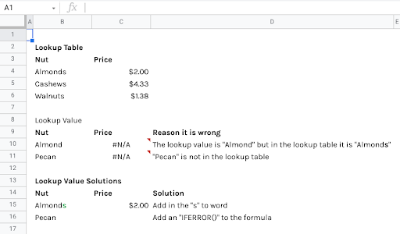Spreadsheet contains three sections: the Lookup Table, the Lookup Value, and the Lookup Value Solutions. The Lookup Table is composed of two columns, Nut and Price. Under Nut, it lists Almonds, Cashews, and Walnuts. Under Price, it lists $2.00, $4.33, and $1.38. In the Lookup Value section, there are three columns: Nut, Price, and Reason it is wrong. Under Nut, it lists Almond and Pecan. But under price, it lists two #N/A errors. Under Reason it is wrong, there is an explanation for both errors. For the first, it states “The lookup value is "Almond" but in the lookup table it is "Almonds". For the second, it states “"Pecan" is not in the lookup table.” In the LookUp Value Solution table, there are three columns: Nut, Price, and Solution. In the Nut column, it lists Almonds and Pecan. Under price, it lists $2.00 for Almonds, and a blank for Pecan. In the Solution columns, it explains what changes were made. For the first row, it states “Add in the "s" to word.” For the second row, it states: “Add an "IFERROR()" to the formula.”

**Example: C10 -** When we select the cell, the error message shows up telling us that the contents of the cell are the result of a VLOOKUP function for “Almond”. Reading the contents in the Formula bar we discover that we are looking up the contents of B10 within the range B4 to C6. You might notice that there is a very small difference in the spelling of “Almond” in cell B10 and “Almonds” in B4.  Just one letter can cause all kinds of errors.

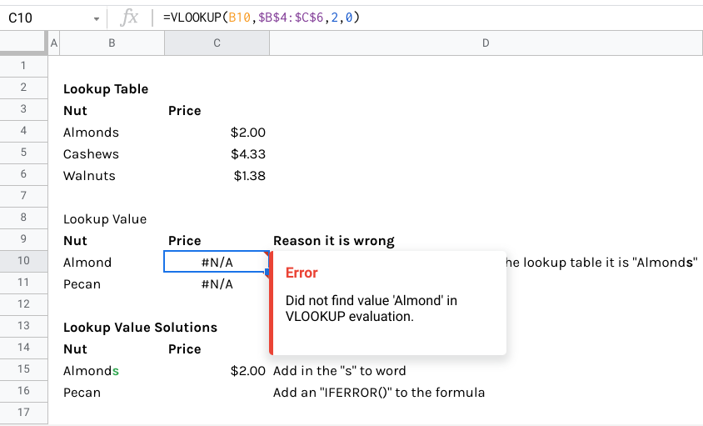Same table as the previous example, but the error message in cell C10 of the LookUp Value table next to Almond has been selected; it states “Did not find value 'Almond' in VLOOKUP evaluation.”

**Solution**: **C11 -** Here, the solution is to simply correct the spelling of Almond to match the Lookup table, which says “Almonds.”

A screenshot of just the LookUp Value Solutions table.A screenshot of just the LookUp Value Solutions table. Cell D15 has been highlighted, and says “Add s to the word.” The s in “Almonds” has been highlighted. This error was solved by fixing the spelling error so that Almonds was consistent in both tables.

**Example: C11**

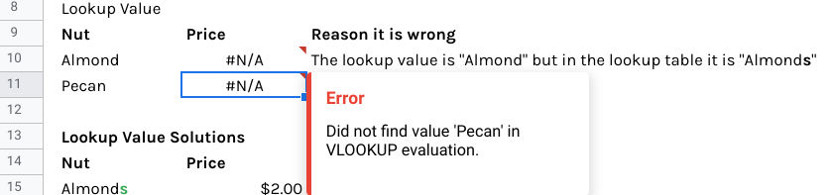Same spreadsheet as previous example, zoomed in on the LookUp Value table. The error in cell C11 next to Pecan has been selected. It reads “Did not find value 'Pecan' in VLOOKUP evaluation.”

**Solution**: **C16 -** “Pecan” doesn’t exist in our table, so we can add **=IFERROR(VLOOKUP(B16,$B$$:$C$6,2,0)," ")** to make this cell blank instead of causing an error.

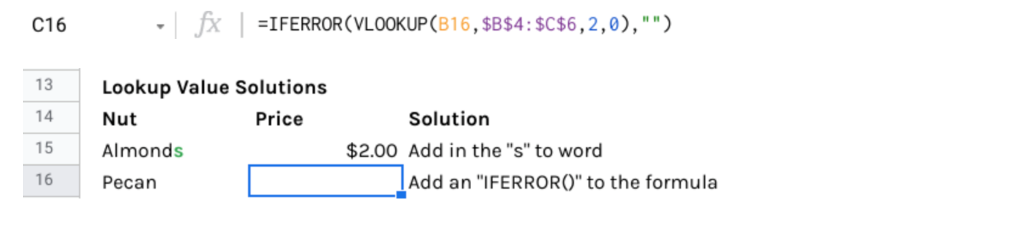Screenshot of the LookUp Value Solutions table. Cell C16 next to Pecan has been selected. The cell is blank, and the new formula reads “=IFERROR(VLOOKUP(B16,$B$4:$C$6,2,0),"")”. Adding an =IFERROR statement solved this error.

## ****#NAME?****

A #NAME? error basically means that your spreadsheet needs help understanding your formula or function. To solve #NAME? errors, the first step is to check your spelling. Then, be sure to use the full name for any formulas or functions. A lot of spreadsheet applications will build formulas and functions for you — or at least help a lot — so it is a good idea to make use of this feature.

### **Misspelled functions**

In the following three examples, the COUNTIF, VLOOKUP, and COUNT functions are spelled incorrectly in Column E as COUNTIIF, VLOOOKUP, and COOUNT. To use these functions, you have to fix the spelling as shown in Column F.

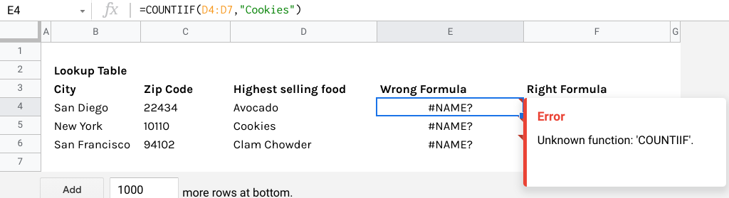Screenshot of a spreadsheet with a table labelled Lookup Table. It has five columns: City, Zip Code, Highest selling food, Wrong formula, and Right formula. Under City, it lists San DIego, New York, and San Francisco. Under Zip Code, it lists 22434, 10110, and 94102. Under Highest selling food, it lists Avocado, Cookies, and Clam Chowder. Under the Wrong Formula column, there are three #NAME? Errors. Cell E4 is selected, which shows the error message “Unknown function: 'COUNTIIF'.” The error message is covering the Right Formula column. The formula reads: “=COUNTIIF(D4:D7,"Cookies")”; COUNTIF contains an extra I.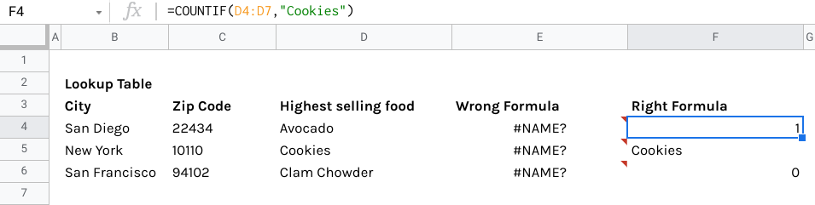Same spreadsheet as the previous example. Now cell F4 in the Right Formula column has been selected. It contains the number 1. The formula now reads “=COUNTIF(D4:D7,"Cookies").” The spelling of COUNTIF has been corrected in this formula. 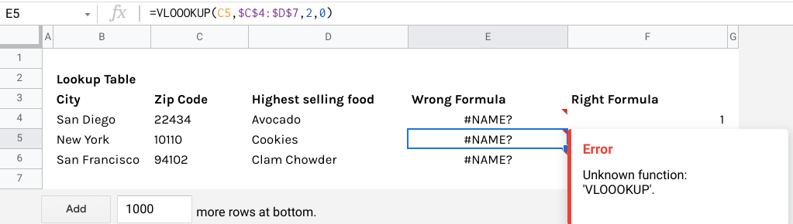Same spreadsheet as the previous example. Cell E5 in the Wrong Formula has been selected. The error message reads “Unknown function: 'VLOOOKUP'.” The formula reads “=VLOOOKUP(C5,$C$4:$D$7,2,0)” with an extra O in VLOOKUP. 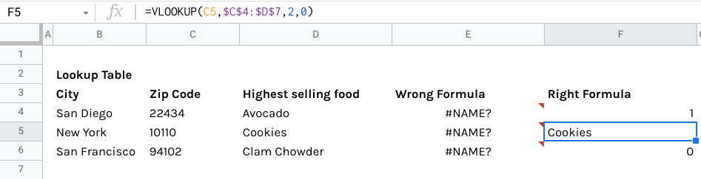Same spreadsheet as the previous example. Cell F5 in the Right Formula column has been selected; it contains the word “Cookies.” The formula reads “=VLOOKUP(C5,$C$4:$D$7,2,0)”; the spelling of VLOOKUP has been corrected.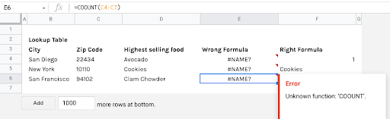Same spreadsheet as the previous example. Cell E6 in the Wrong Formula column has been selected. The error message reads “Unknown function: 'COOUNT'.” The formula reads “=COOUNT(C4:C7)” with an extra O in COUNT.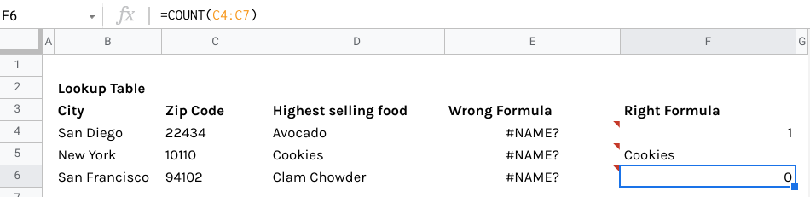Same spreadsheet as the previous example. Cell F6 in the Right Formula column has been selected. The cell contains the number 0. The formula reads “=COUNT(C4:C7)”; the spelling of COUNT has been corrected.

## ****#NULL!****

A #NULL! error means that you have specified two or more ranges — collections of cells — that are supposed to overlap, but don’t actually intersect. To fix a #NULL! error, there are two common solutions: First, use a colon (:) to separate the first cell from the last cell when you refer to a continuous range of cells in a formula. Or, use a comma (,) between ranges to tell your spreadsheet that they are actually separate. This error might show up differently depending on what program you are using; for example, this can appear as #ERROR! in Google Sheets.

**Example:** =COUNT(B1:D1 C1:C10)

**Solution:** =COUNT(B1:D1,C1:C10)

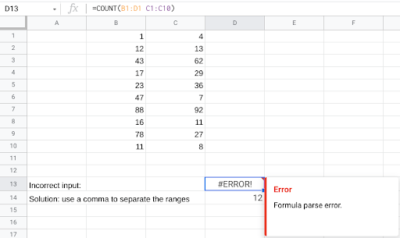Screenshot of a spreadsheet. In columns B and C, there is a list of numbers. Column B contains 1, 12, 43, 17, 23, 47, 88, 16, 78, and 11. Column C contains 4, 13, 62, 29, 36, 7, 92, 11, 27, and 8. Underneath the lists of numbers, cell A13 contains the text “Incorrect input:”; cell D13 contains an #ERROR! Message. The error message states “Formula parse error.” The formula reads “=COUNT(B1:D1 C1:C10).” In cell A14, it states that the solution: “use a comma to separate the ranges.” Cell D14 contains the number 12.

In this example, there is no comma between the cell ranges being selected, which makes it impossible for the spreadsheet to read the formula.

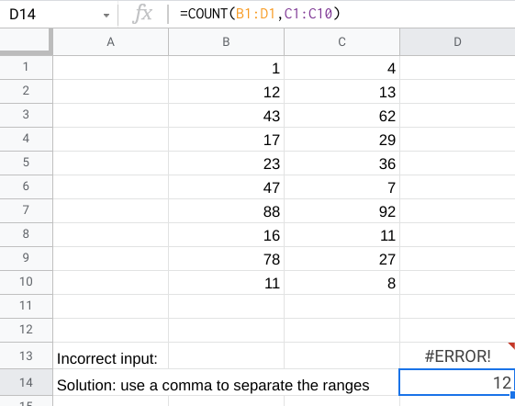Same spreadsheet as the previous example. Cell D14 with the corrected formula has been selected. The formula reads “=COUNT(B1:D1,C1:C10)” with a comma separating the ranges.

By adding the comma between the cell ranges, you can fix this error.

## ****#NUM!****

A #NUM! error means that the spreadsheet can’t perform a calculation as written. This can happen for a few reasons. The numbers might be too big or small for the spreadsheet to process, the calculation might be impossible, or there is something wrong with the variables that have been input. To fix a #NUM! error, your best bet is to just return to your formula and double-check it.

**Example:** In this example, the spreadsheet can’t use this formula because the Start Date is greater than the End Date; this mistake needs to be corrected before the formula will work.

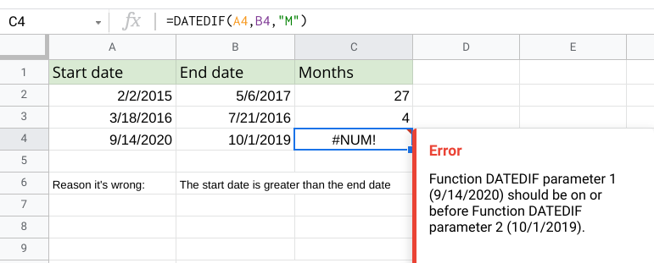Screenshot of a spreadsheet. There are three columns: Start date, End date, and Months. In the Start date column, it lists 2/2/2015, 3/18/2016, and 9/14/2020. In the End date column, it lists 5/6/2017, 7/21/2016, and 10/1/2019. In the Months column, it lists 27, 4, and a #NUM! Error. The cell with the error, C4, has been selected; The formula reads “=DATEDIF(A4,B4,"M").” The error message reads “Function DATEDIF parameter 1 (9/14/2020) should be on or before Function DATEDIF parameter 2 (10/1/2019).” Underneath the table, there is text: “Reason it’s wrong: the start date is greater than the end date.”

**Solution:** Switching the dates so that they’re in the correct order fixes this formula.

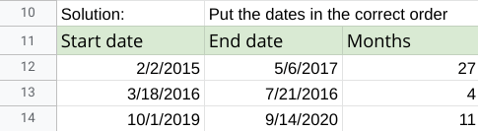Screenshot of the corrected table from the previous example. Above the table, it reads “Solution: Put the dates in the correct order. The dates from row 14, 9/14/2020 and 10/1/2019 have been flipped. Now the cell under the Months column contains 11 instead of the error message.

## ****#REF!****

A #REF! error tells you that your formula or function is referencing a cell that is not valid. In other words, a cell or range may be missing. To solve this, just make sure you are giving your formula or function only valid cells by double-checking the reference.

**Example (Correct the reference):** In this example, a row was deleted from the original calculation, but it wasn’t updated in the formula.

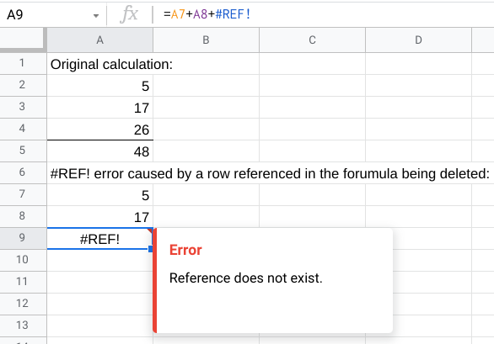Screenshot of a spreadsheet. Under the text “Original calculation:” cells A13-A15 are being added together. The cells contain the numbers 5, 17, and 26; the solution in cell A5 is 48. Underneath the original calculation, the spreadsheet states that “#REF! error caused by a row referenced in the formula being deleted:” and shows a similar calculation to the one above using rows A18-A20. However, this time, the third row has been deleted, and there is a #REF! Error in the cell with the solution. The error message reads “Reference does not exist.” The formula reads “=A18+A19+#REF!”

**Solution (Correct the reference):** We can fix this error by updating the formula and removing the missing row from the calculation.

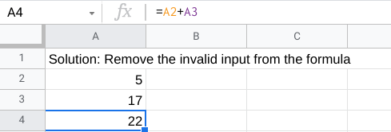Screenshot of the solution to the previous example’s error. The text reads “Solution: Remove the invalid input from the formula.” #REF! Has been removed from the formula, so now it is “=A2+A3.” The cell with the solution contains the number 22.

## ****#VALUE!****

A #VALUE! error means that there are spaces, characters, or text in your formula or function, which should actually be numbers. You can solve this problem by making sure they are either eliminated or numerical.

**Example (Wrong type of data):** In this example, a text string has been added to the End Date column instead of a date. This means the spreadsheet can’t perform the calculation.

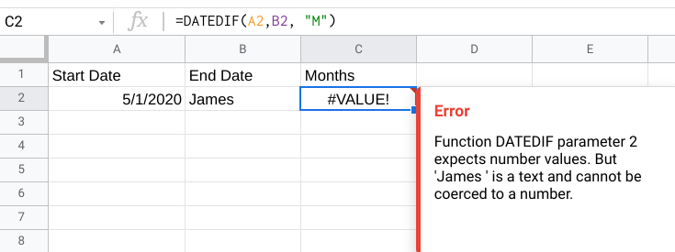Screenshot of a spreadsheet. There are three columns: Start Date, End Date, and Months. Under Start Date, it contains 5/1/2020. Under End Date, it contains the name James. The formula reads “=DATEDIF(A2,B2, "M").”There is a #VALUE! Error under the Months column; the message reads “Function DATEDIF parameter 2 expects number values. But 'James ' is a text and cannot be coerced to a number.”

**Solution (Wrong type of data):** Input the correct data type to make this formula possible.

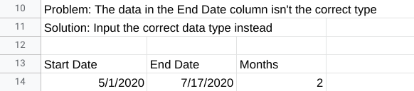Corrected spreadsheet from the previous example. It includes a description of the problem: “Problem: The data in the End Date column isn't the correct type.” And the solution: “Solution: Input the correct data type instead.” The entry in the End Date column has been changed to the date 7/17/2020, allowing the formula to run correctly. Under the Months column, it lists 2.

## Spreadsheet error resources

To learn more and see additional examples of errors and solutions, explore these resources:

* [**Microsoft Formulas and Functions**](https://support.microsoft.com/en-us/office/formulas-and-functions-294d9486-b332-48ed-b489-abe7d0f9eda9?ui=en-US&rs=en-US&ad=US#id0eaabaaa=errors)**:** This resource describes how to avoid broken formulas and how to correct errors in Microsoft Excel. This is a useful reference to have saved in case you run into a specific error and need to find solutions quickly while working in Excel.
* [**When Your Formula Doesn’t Work: Formula Parse Errors in Google Sheets**](https://www.benlcollins.com/spreadsheets/formula-parse-error/): This resource is a guide to finding and fixing some common errors in Google Sheets. If you are working with Google Sheets, you can use this as a quick reference for solving problems you might encounter working on your own.

With some practice and an investigative spirit, you will become much more comfortable handling errors in spreadsheets. Each error you catch and fix will make your data clearer, cleaner, and more helpful.